Richard was a professional musician graduating from Leeds College of Music in 1986 where he studied guitar and composition. Leeds was one of the only colleges, at that time in the UK, which specialized in a degree in Light Music. This led Richard to play with and tour with TV stars of that time such as Ronnie Corbett, Charlie Drake, Les Denis , Dana, The Platters and Tony Christie to name but a few.

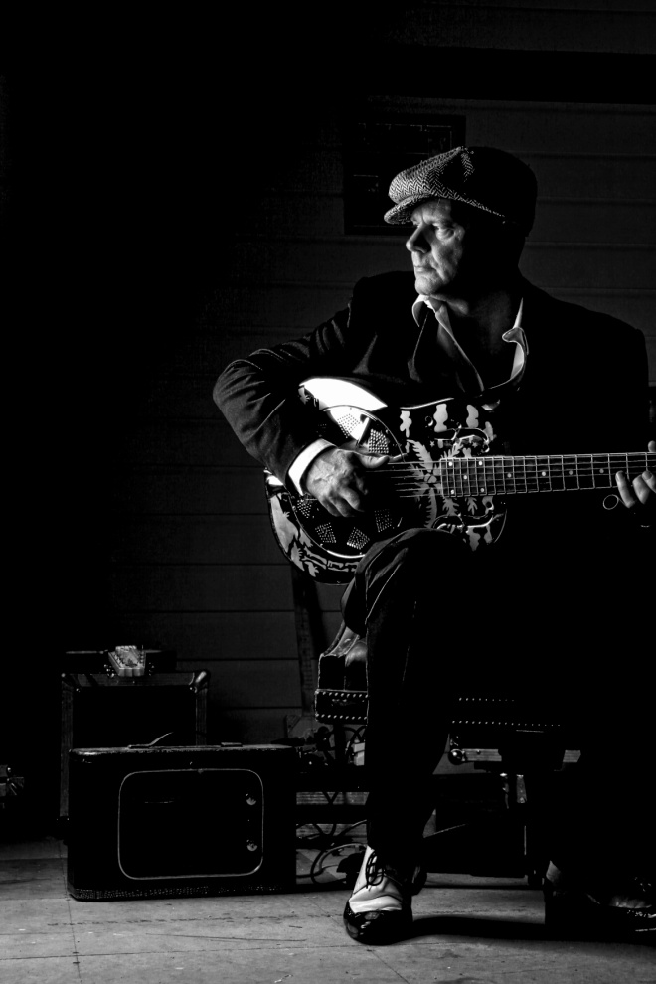Richard Townend

When he moved to London in the late eighties, he decided to leave the professional music field and play for fun after becoming disillusioned with the professional music scene. Soon the fun dried up and he hung his guitar up for good when he moved to Essex in 2000.

Bewick Suite Jam

Later in that decade he was inspired (after watching a jam session at the Bewick Suite in Maldon Essex) to start to play again. He got his guitars out of hock, formed the Boss Cats, and gigged as a hard rocking blues trio in the style of Stevie Ray Vaughn; later to morph into the cool sound of the Mighty Boss cats in a more relaxed incarnation.

In 2011 he decided to write and record in a more serious nature culminating in 12 album releases in the period Jan 2011 – Jun 2020 with a 13th one being worked on and planned to be completed in quarter 2 2021. The 12th been a live album recorded in Moscow

He also uniquely creates videos for these album songs which can be found on the ‘themightybosscats’ you tube channel. www.youtube.com/themightybosscats. There are over 100+ of these videos ; they also appear on his web site

The albums have received critical acclaim and have a contemporary eclectic feel to them, mixing his Blues, Jazz, Country and many other musical influences. He has been nominated no less than 5 times for his songs in the British Blues Awards for original song in 2012/13/14 and was also nominated in band, album male vocals and acoustic act 2014 and album for the year 2019.

His lyrical content and subject matter are also praised, Richard writes songs and not 12 bar guitar solos with a few words thrown in for measure. He is often called prolific having recorded over 100 songs in the last 10 years – although written nearer 250

He is favorably compared to JJ Cale, Chris Rea and Dire Straits. He plays solo or with the band depending on venue size or requirements of the sponsor. He has played in the USA, EUROPE, ASIA and AUSTRALIA and nationally all around the UK.

The solo work encompasses an exciting array of self penned songs looped into a full band sound as he plays. His web site has more information: -

www.richardtownend.com

- "It's hard not to view Townend as a sort of latter day Mark Knopfler. His lyricism and fretwork both share echoes of the former Dire Straits leader " Elmore Magazine New York
​
- "Always working on musical projects, he seems to have incredible energy and a wonderful grasp on blues and light rockbased modern music " Blues Matters
​
- “Melancholic, relaxed and enthralling: Richard Townend is a fascinating songwriter in the world of Blues. With The MightyBosscats he has a band on the side that make his songs prime examples of contemporary blues ...." Wasser-Prada.de
​
- "Three albums show some of the best of the modern age –three albums from out of nowhere, created by musicians for the love of it. ............... Really fine music ........." Blues Matters
- “Melancholic, relaxed and enthralling: Richard Townend is a fascinating songwriter in the world of Blues. With The Mighty Bosscats he has a band on the side that make his songs prime examples of contemporary blues” WASSER-PRAWDA.DE
- "Three albums show some of the best of the modern age – three albums from out of nowhere, created by musicians for the love of it. ............... Really fine music ........." BLUES MATTER
- "...........including the exceptional and exceptionally atmospheric ‘Hang An Innocent Man’, prove Townend is a great writer as well as musician" BLUES MATTERS
- "Don’t let the easy-going swing of this tune make you ignore the astonishing nature of the acoustic guitar solo that is frankly breathtaking both in musicianship and in sense of melody.............." PANIC MAGAZINE
Please Subscribe : www.youtube.com/themightybosscats

